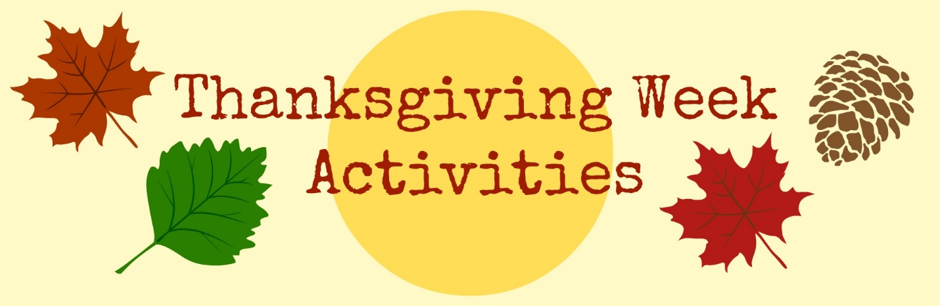

Joe’s Club has the best staff and deserves a great week of THANKS!
Comfy Jeans All Week!

McDonald’s Monday | 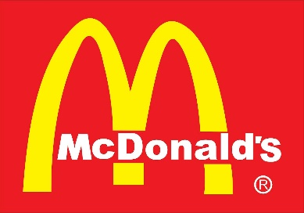 | Hamburgers, Cheeseburgers and Fries
Taco Bell Tuesday | 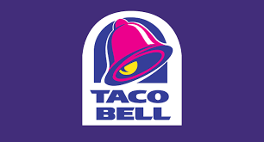 | Tacos, Burritos and Cinnamon Twists
Wendy’s Wednesday | 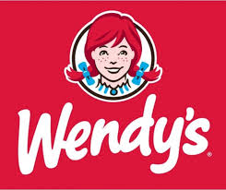 | Chicken Nuggets and Fries
Thursday | PAID DAY OFF!!!
Pizza Party Friday | 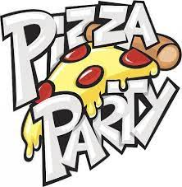 | Pizza and Garlic Knots

