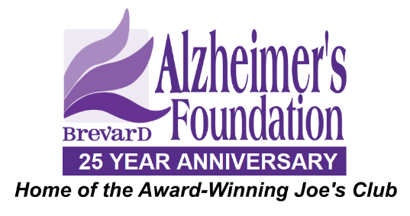
Due to the 2019-2020 outbreak of the novel Coronavirus (COVID-19), the Brevard Alzheimer’s Foundation is taking extra precautions with the care of every client to include health history review and enhanced sanitation/disinfection procedures in accordance with the Florida Department of Professional Regulation guidance.
Symptoms of COVID-19 include:
- Fever
- Fatigue
- Dry Cough
- Difficulty Breathing
I agree to the following:
q I understand the above symptoms and affirm that I, as well as all household members, do not currently have, nor have experienced the symptoms listed above WITHIN THE LAST 14 DAYS.
q I affirm that I, as well as all household members, have not been diagnosed with COVID-19 WITHIN THE PAST 30 DAYS.
q I affirm that I, as well as all household members, have not knowingly been exposed to anyone diagnosed with COVID-19 WITHIN THE PAST 30 DAYS.
q I affirm that I, as well as all household members, have not traveled outside of the country, or to any city considered to be a "hot spot" for COVID-19 infections WITHIN THE PAST 30 DAYS.
I understand that Brevard Alzheimer’s Foundation cannot be held liable for any exposure to the COVID-19 virus caused by misinformation on this form or the health history provided by each client.
Brevard Alzheimer’s Foundation is following these enhanced procedures to prevent the spread of COVID-19:
- Social distancing of all clients throughout the day.
- Each client required to sanitize hands upon arrival and before leaving
- Each client is temperature checked upon entry of the building
- All visitors and vendors must be temperature checked upon entry of the building
- All volunteer entertainment has been cancelled indefinitely
- All staff will thoroughly clean hands and wear gloves while toileting clients
All surfaces will be wiped thoroughly with hospital grade disinfectant before and after each use by the client according to the manufacturer's directions
By signing below, I agree to each statement above and release Brevard Alzheimer’s Foundation from any and all liability for the unintentional exposure or harm due to COVID-19.
Brevard Alzheimer’s Foundation agrees to abide by these standards and affirms the same.
___________________________ ___________________________ ___________________________
Caregiver Client Date

JOE’S CLUB COVID 19 PROTOCOLS

- All staff providing direct care must wear eye shield and face mask.

- All staff must get temperature taken upon entering building and sanitize hands.

- All staff will refrain from coming to work if demonstrating any symptoms. Must be symptom free for 72 hours.

- All members will have temperature and O2 sats taken and sanitize prior to entering dayroom.

- Any member presenting any symptoms will not be permitted to remain in ADC (Including but not limited to Temperature, cognitive changes, decreased 02 sats, cough, runny nose, etc). Caregiver will be contacted to come and pick member up. Must be symptom free for 72 hours before returning.

- No personal mobility equipment to enter building. Members may use ADC provided equipment.

- All walkers and restrooms will be sanitized in between each member use.

- No showers provided by ADC staff until further notice

- No transportation provided by ADC until further notice

- Melbourne Max capacity to be 40 members. 3 members per table.

- (Capacity to be evaluated regularly by Executive Director/Clinical Staff).

